NAME: SHYAM SUNDAR K
ROLL NO: 241801268
DPT: AI&DS SEC: ‘FD’
EXERCISE NO: 3
1. Add a table-level PRIMARY KEY constraint to the EMP table on the ID column.The
constraint should be named at creation. Name the constraint my_emp_id_pk.
Sol

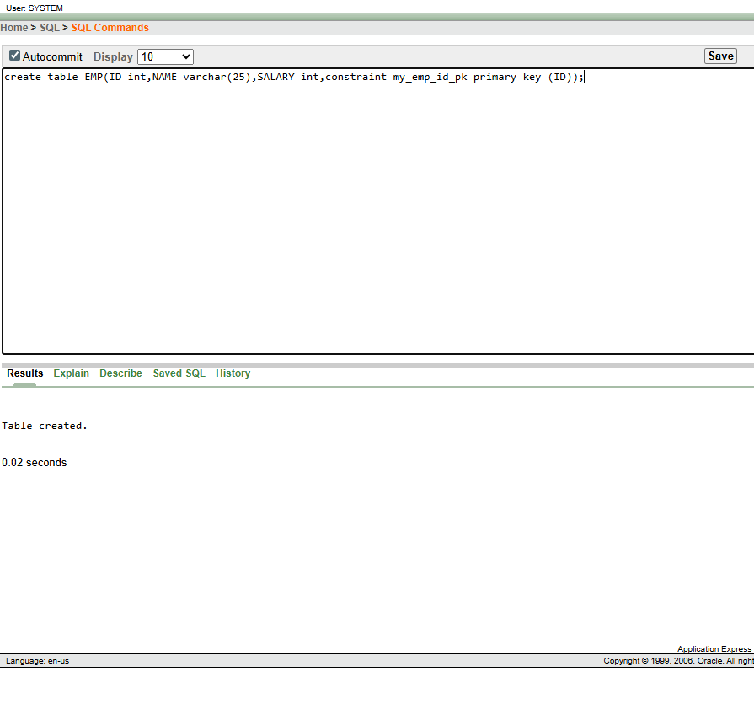
2, Create a PRIMAY KEY constraint to the DEPT table using the ID colum. The constraint
should be named at creation. Name the constraint my_dept_id_pk.

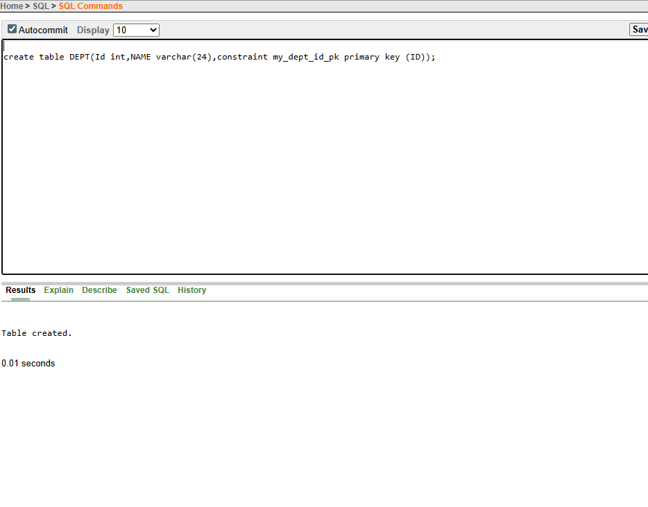
3, Add a column DEPT_ID to the EMP table. Add a foreign key reference on the EMP table
that ensures that the employee is not assigned to nonexistent deparment. Name the constraint
my_emp_dept_id_fk.
Sol;
alter table EMP
add DEPT_ID int;
alter table EMP
add constraint my_emp_dept_id_pk
foreign key (DEPT_ID) references DEPT(ID);
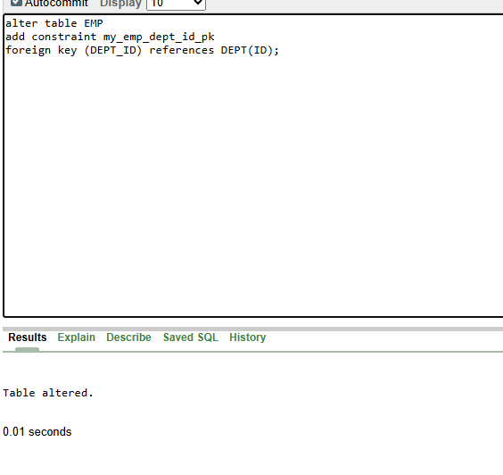
4, Modify the EMP table. Add a COMMISSION column of NUMBER data type, precision 2,
scale 2. Add a constraint to the commission column that ensures that a commission value is greater
than zero.
Sol :
alter table EMP
add COMMISSION number(2,2);
alter table EMP
add constraint COMMISSION
check(COMMISSION > 0);

